**PROG7311 POE PART 1**

**Imaan Ebrahim**

**ST10021922**

**PROG7311**

AGRI-ENERGY CONNECT: A Digital Platform for Eco-Friendly Farming and Renewable Energy

Introduction:

The goal of the Agri-Energy Connect platform is to close the divide between the agricultural industry and providers of green energy technology. This platform will enable cooperation, information exchange, and creativity in the fields of sustainable agriculture and renewable energy by establishing a digital ecosystem.

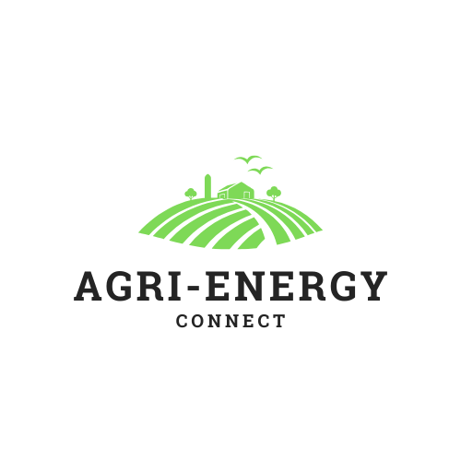

Non-Functional Requirements:

Non-functional requirements (NFRs) play a vital role in the success of the Agri-Energy Connect platform. The following non-functional requirements are comprised of:

* **Scalability:** The platform needs to manage higher levels of user traffic and data amount as the user community expands. This can be accomplished by:  
  -Cloud infrastructure that can automatically adjust resources as needed.  
  -Balancing the load to evenly spread-out traffic among several servers.  
  -Techniques for optimizing databases and implementing caching.
* **Security:** Ensuring the security of private user information and avoiding unauthorized entry is of utmost importance. This can be accomplished by:  
  -Strong authentication and authorization mechanisms.  
  -Powerful encryption methods for data when it is stored and being transferred.  
  -Frequent security evaluations and vulnerability assessments.

- Secure coding practices to minimize vulnerabilities (Troelsen & Japikse, 2017)

* **Usability:** The platform should be easy to use and intuitive for both farmers and employees. This can be accomplished by:  
  -Concise and clear design of the user interface.  
  -Simple and easy-to-follow navigation for users.  
  -Conducting user testing to discover and resolve usability problems.

- Adherence to accessibility standards (WCAG) to ensure the platform is usable by people with disabilities (Troelsen & Japikse, 2017)

* **Performance:** The platform needs to be prompt in addressing user inquiries and offer a smooth user experience. This can be accomplished by:  
  -Efficiently executed database inquiries and storage techniques.  
  -Reducing data transfer delays on the network.

- Asynchronous programming techniques to improve responsiveness (Troelsen & Japikse, 2017)  
-Observing and adjusting performance.

Design and Architecture Patterns

Design and architectural patterns are crucial for constructing sturdy and sustainable software systems. We suggest the following templates for the Agri-Energy Connect platform.

* **Model-View-Controller(MVC):**

This design divides the application's concerns into three separate layers: the model, the view, and the controller. This contributes to the structuring of code, its testability, and ability to be maintained (Troelsen & Japikse, 2017).

* **Repository Pattern:**

This design pattern consolidates data access logic, enhancing code modularity and testability. It additionally offers a level of separation between the data access layer and the business logic layer (Troelsen & Japikse, 2017).

* **Dependency Injection:**

This design encourages a relaxed connection between components, enhancing the flexibility and testability of the code. It enables simple replacement of components with alternative implementations (Troelsen & Japikse, 2017).

Utilizing these patterns allows for the development of a structured, easily maintained, and flexible application.

**Conclusion:**

By meeting the essential non-functional needs of scalability, security, usability, and performance, the Agri-Energy Connect platform offers a strong and dependable answer for farmers and energy providers. Utilizing design patterns like MVC, Repository, and Dependency Injection will improve the platform's ability to be maintained, tested, and scaled.  
  
According to Troelsen and Japikse (2017), a properly designed architecture is essential for the ultimate success of a software project. By following recommended methods and utilizing common tools and technologies, we can guarantee that the Agri-Energy Connect platform brings benefits to its users and helps advance a sustainable future.

**Visual Aids:**

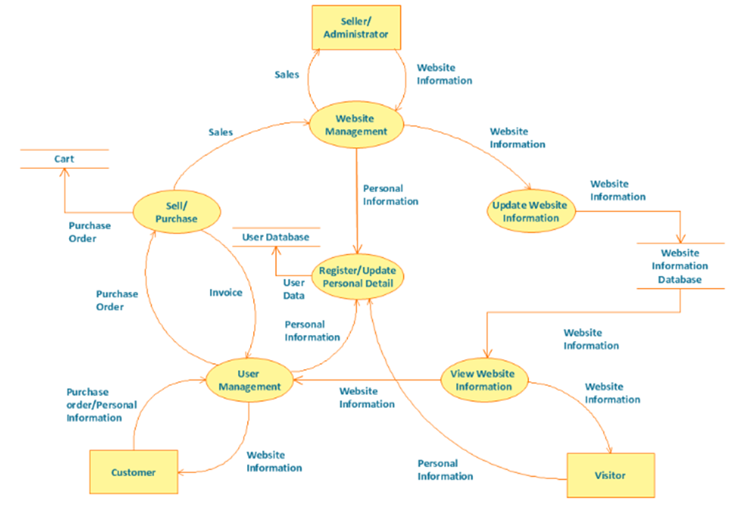Diagram showing the flow and structure of an online store.

Source: <https://www.conceptdraw.com/How-To-Guide/online-store-dfd>

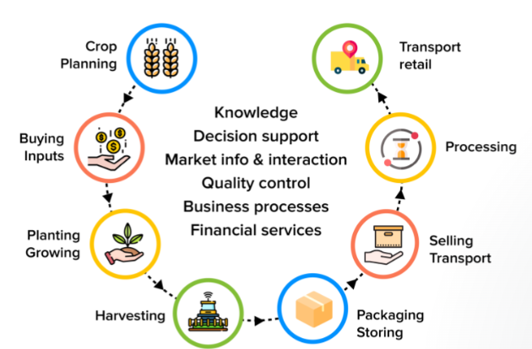Diagram showing the process of how an agricultural based app works.

Source: <https://appinventiv.com/blog/mobile-app-role-in-agriculture/>

WORDS: 543

**References:**

Humanity’s Promise International. (2023). Donate an Acre of Land. [online] Available at: https://humanityspromise.com/donate-to-humanitys-promise-international/donate-an-acre-of-land/?gad_source=1&gclid=CjwKCAjww_iwBhApEiwAuG6ccIGpY-tY2jViP-vCen5qcjK6CdB0AWAEUdPVwCfWZ0H57mywvNnMBBoCqNEQAvD_BwEEditor (2023).

10 Agricultural techniques for water conservation. [online] www.green.earth. Available at: https://www.green.earth/blog/10-agricultural-techniques-for-water-conservationBioProtection

Portal. (n.d.). Soil health: why it’s important and how to protectit. [online] Available at: https://bioprotectionportal.com/resources/soil-health-importance-and-how-to-protect/?gad_source=1&gclid=CjwKCAjww_iwBhApEiwAuG6ccDSFeBF83wEVreDCz9u2E8AdY3WVWmx6EPedHD21OrEY_RlaOwhGyBoCqQQQAvD_BwE

nextbillion.net. (n.d.). Preparing Young Leaders to Solve the World’s Energy Challenges: Insights From Nine Business Case Studies Highlight Paths to a Sustainable Future - NextBillion. [online] Available at:https://nextbillion.net/empowering-young-leaders-energy-challenges-business-case-studies-sustainable-future/?gad_source=1&gclid=CjwKCAjww_iwBhApEiwAuG6ccKua10sqPV8nDeaceOGRn7Ex0kx7LxM-PeRC2lxH1Jmd_BJV_ZvVIBoCbr4QAvD_BwEStackHawk. (n.d.). Web Application Security Checklist:

10 Improvements. [online] Available at: https://www.stackhawk.com/blog/web-application-security-checklist-10-improvements.Raheja,

S. (2024). How to Optimize Performance in Custom Software Development. [online] Taazaa. Available at: https://www.taazaa.com/performance-optimization/.Webflow. (n.d.).

User-centered design: 4 key principles and how to apply them in web design | Webflow Blog. [online] Available at: https://webflow.com/blog/user-centered-design?utm_source=google&utm_medium=search&utm_campaign=SS-GoogleSearch-Nonbrand-DynamicSearchAds-Core&utm_term=dsa-45211625058___547699967189__&gad_source=1&gclid=CjwKCAjww_iwBhApEiwAuG6ccGmY4VeBdQ35UsXO5EQHFe8dfTAfHiXIXfXUKphQH5syQ76BDtudRRoC1UQQAvD_BwEGeeksforGeeks (2018).

MVC Design Pattern - GeeksforGeeks. [online] GeeksforGeeks. Available at: https://www.geeksforgeeks.org/mvc-design-pattern/.Sharma, L. (2021). Best practice and Cheat sheet for REST API Design. [online] ByteByteGo System Design Alliance. Available at: https://medium.com/bytebytego-system-design-alliance/best-practice-and-cheat-sheet-for-rest-api-design-6a6e12dfa89fwww.linkedin.com. (n.d.). How can you use the repository pattern to managedata in your web app? [online] Available at: https://www.linkedin.com/advice/0/how-can-you-use-repository-pattern-manage-data-giacc#:~:text=The%20repository%20pattern%20is%20a

Mosyan, D. (2023). Asynchronous event-driven communication. [online] Medium. Available at: https://medium.com/@dmosyan/asynchronous-event-driven-communication-34a43d16dea9www.wri.org. (2023). African Energy Dialogues: Energising the Future Together | World Resources Institute. [online] Available at:https://www.wri.org/initiatives/african-energy-dialogues?utm_source=google&utm_medium=paid-search-google-grants&utm_campaign=african-energy-dialogues&gad_source=1&gclid=CjwKCAjw5v2wBhBrEiwAXDDoJeRG-XzdF5rAhAA008kQHA6zaGYeicEmOD5f5Z8Gif2HjEQRXUtYURoCg88QAvD_BwE